1. Create project and application

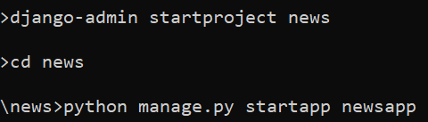

1. Register application in settings.py
2. Create templates folder
3. Register templates folder
4. Create following folder and files in templates folder
   1. templates > base.html
   2. templates > politics > politics.html
   3. templates > sports > sports.html
   4. templates > bollywood > bollywood.html

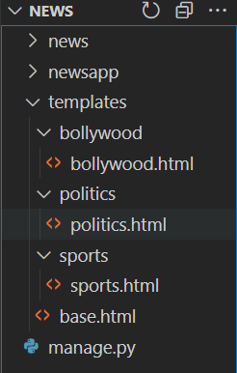

1. create static folder and register it in settings.py

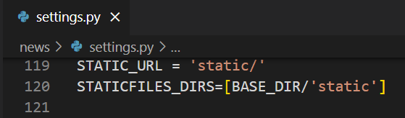

1. create static > css > politics.css, sports.css, bollywood.css

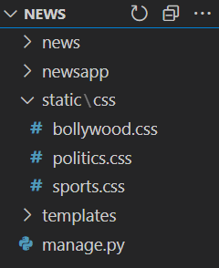

1. create view to display base.html as home page

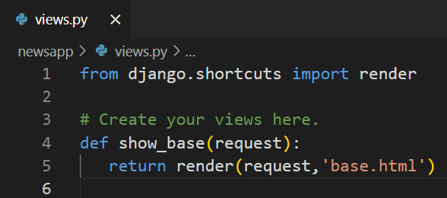

1. create news_urls.py in newsapp folder to create application level url

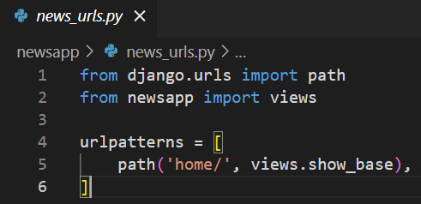

1. include above news_urls.py in urls.py

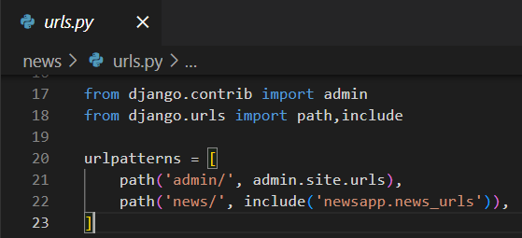

1. add basic code of bootstrap into base.html

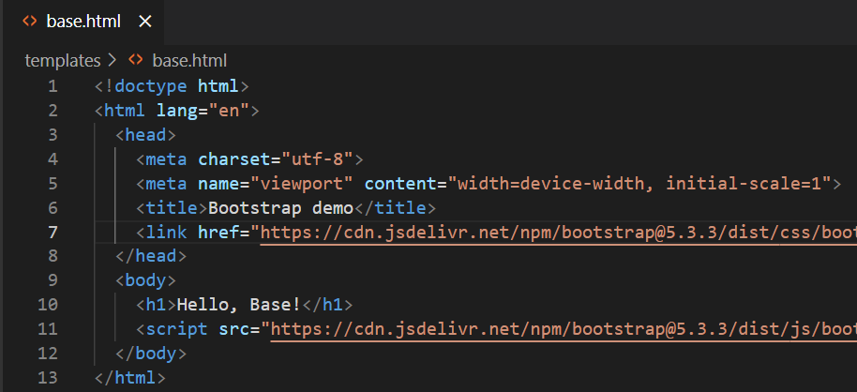

1. runserver and check output

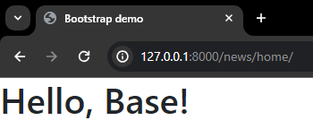

1. add navbar code from bootstrap to base.html

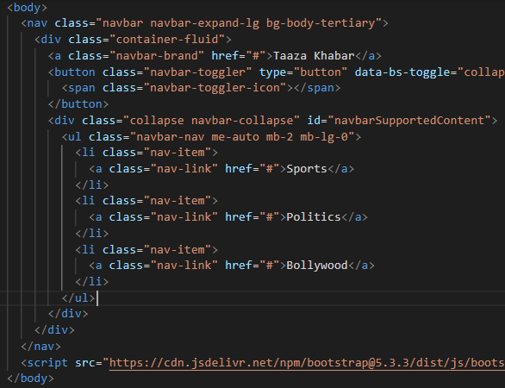

1. output

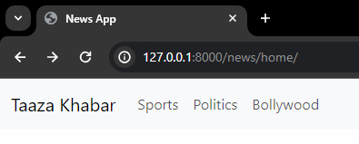

1. showing sports news on clicking sports from navbar
   1. add <h1>Welcome to sports news</h1> to the body of sports.html
   2. create view to show sports.html

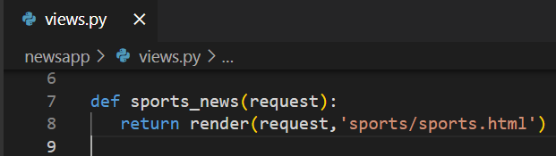

* 1. create url for above view in news_urls.py

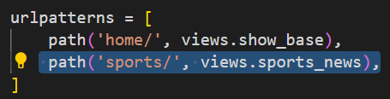

* 1. add above url in navbar of base.html

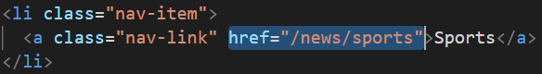

* 1. output

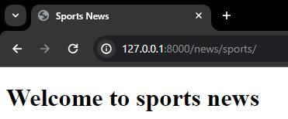

1. Template inheritance example :
   1. Create 2 blocks in base.html (you can create as many as you want)

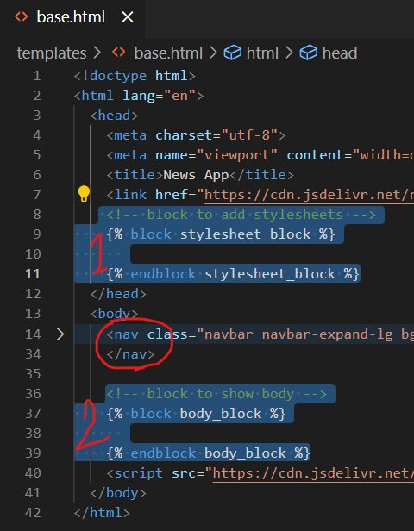

* 1. Update sports.html by adding code inside block

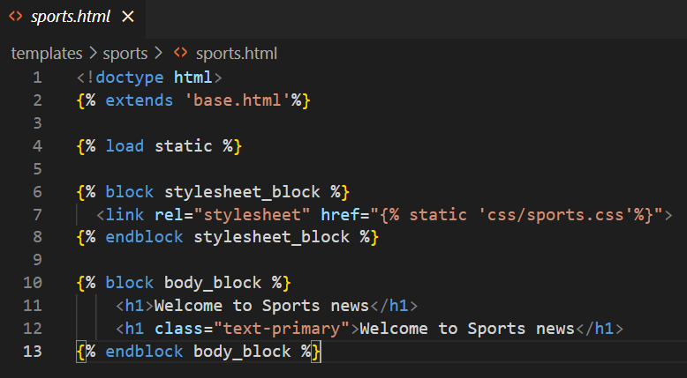

* 1. Code for sports.css

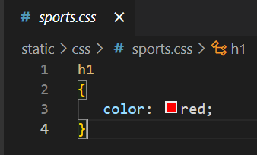

* 1. Output

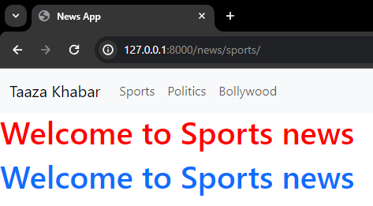

1. DIY for politics and bollywood